**Introduction**

**Title:** Image Processing with AWS Lambda

* **Introduction:**
  + Overview of the project.
  + Goals: Convert uploaded images to black and white, store in S3, and email results.

To accomplish the described task, you can follow these general steps using AWS services:

**Architecture Overview**

**Title:** System Architecture

* **Components:**
  + S3 Buckets (Source)
  + Lambda Function
  + SES (Simple Email Service)
* **Flow:**
  + Image upload triggers Lambda.
  + Lambda processes the image and stores it in the Destination S3 bucket.
  + Email sent with original and processed images.

**AWS Resources Setup**

**Title:** Setting Up AWS Resources

* **Tasks:**
  + Create two S3 buckets.
  + Set up an IAM role for Lambda.
  + Configure SNS for sending emails.

**1.0 Amazon S3:**

* + Create two S3 buckets, one for the original images and one for the processed (black/white) images.

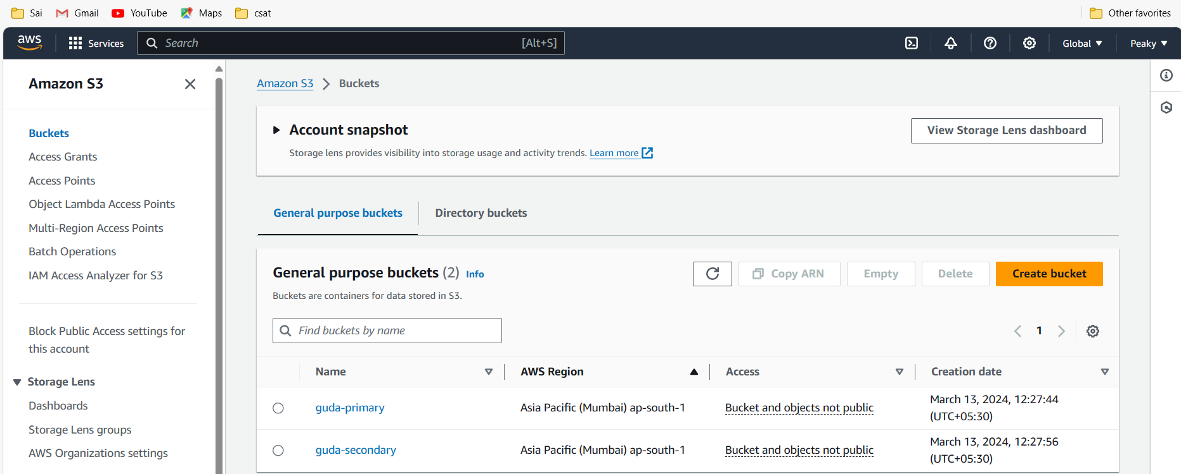

**Lambda Function**

**Title:** Lambda Function Configuration

* **Configuration:**
  + Create a Lambda function.
  + Set up the IAM role with necessary permissions.
  + Configure S3 trigger event.
* **Code:**
  + Python code using OpenCV for image processing.

**2.0 AWS Lambda:**

* Create an AWS Lambda function that triggers on an S3 bucket event (e.g., object creation).

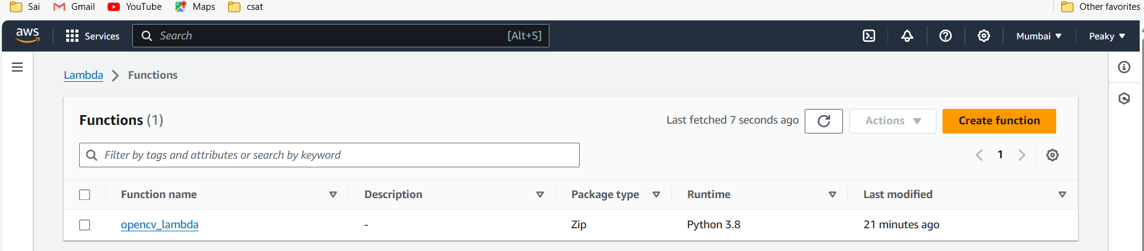



* Configure the Lambda function to use the appropriate IAM role with permission to read from the source S3 bucket, write to the destination S3 bucket, and send emails.

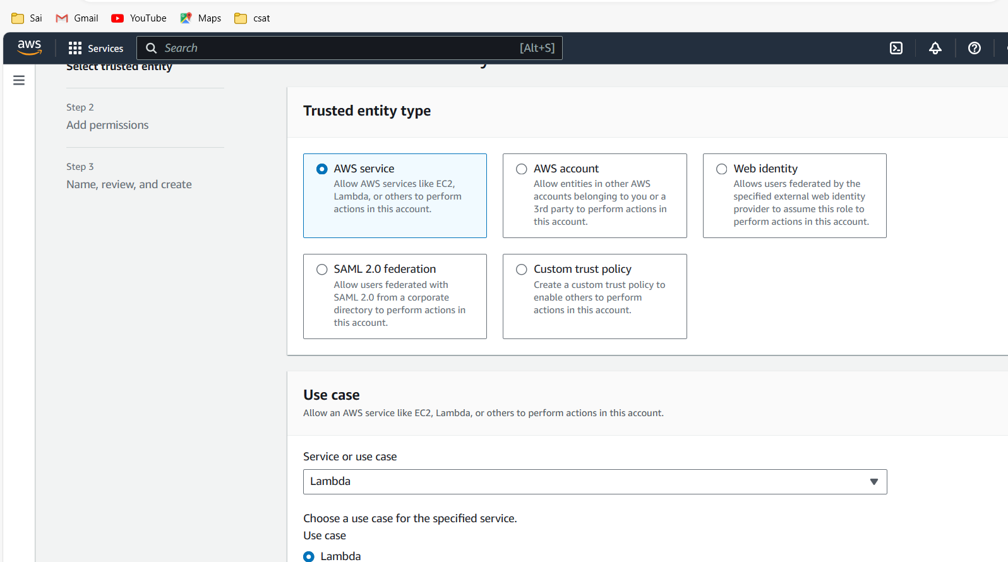

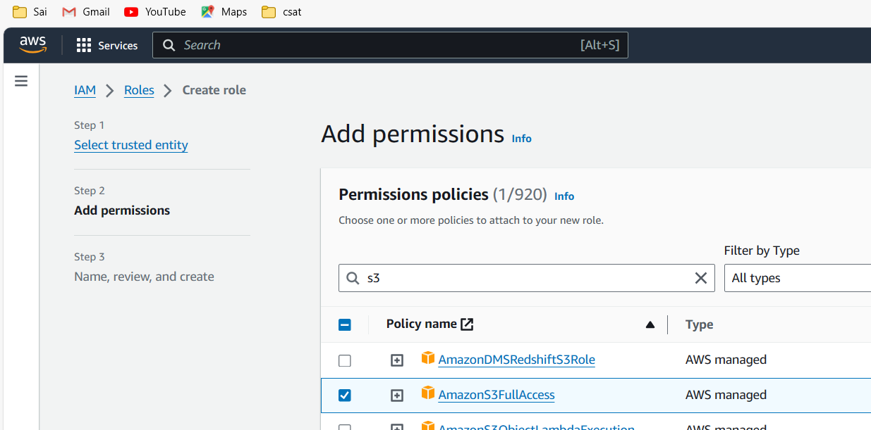

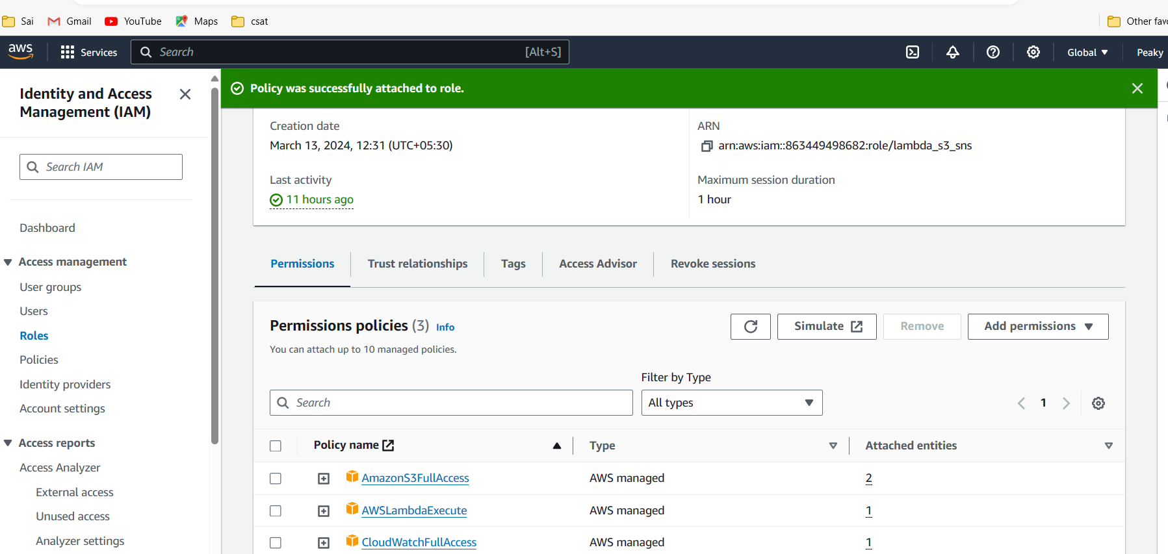

In Lambda-Add Trigger:

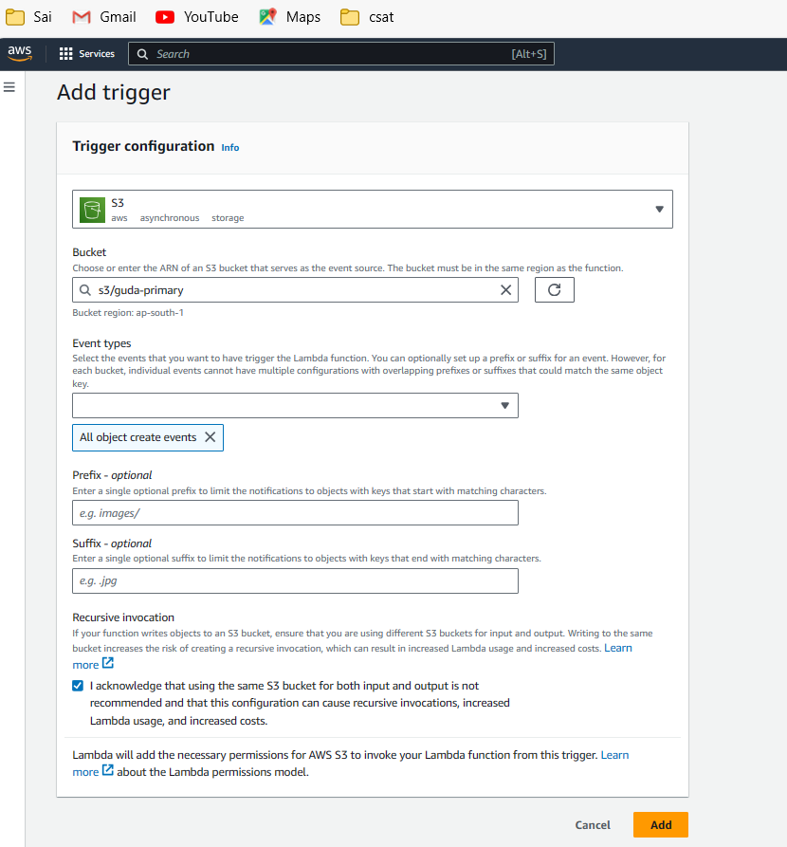

**3.0 Python with OpenCV:**

* Write a Lambda function in Python that uses the OpenCV library to convert the image to black/white.
* Ensure that the necessary OpenCV dependencies are included in the deployment package.

**OpenCV** is a huge open-source library for computer vision, machine learning, and image processing. OpenCV supports a wide variety of programming languages like Python, C++, Java, etc. It can process images and videos to identify objects, faces, or even the handwriting of a human.

Certainly! **OpenCV** (Open-Source Computer Vision Library) is a powerful tool for computer vision, image processing, and machine learning tasks. It provides a wide range of functions and algorithms to work with images, videos, and other visual data. Here are some details about using OpenCV in Python:

**Importing Package into our Lambda Layers:-**

**Steps:**

1. Connect to UBUNTU VM from EC2 and run the following commands to install required packages for the project.

Step-by-Step Commands

sudo apt-get update -y

python3 –version

It seems that Python 3.8 isn't available directly from the default Ubuntu repositories on your EC2 instance. Here’s an alternative approach to install Python 3.8 and set up your environment:

### Installing Python 3.8 on Ubuntu EC2

1. **Add Deadsnakes PPA (Personal Package Archive):** This PPA provides newer Python versions not available in the default Ubuntu repositories.

sudo add-apt-repository ppa:deadsnakes/ppa

sudo apt-get update

**Install Python 3.8:** Now that you've added the repository, you can install Python 3.8.

sudo apt-get install -y python3.8

**Install python3.8-venv for virtual environments:**

Python's built-in module for creating virtual environments.

sudo apt-get install -y python3.8-venv

**Verify Python 3.8 installation:** Check the installed version.

python3.8 –version

### Setting up Your Lambda Deployment Package

After installing Python 3.8, you can proceed to set up your Lambda deployment package:

1. **Create a virtual environment for Python 3.8:**

Sudo python3.8 -m venv myenv

source myenv/bin/activate



Install AWS CLI and necessary tools:

sudo apt-get install -y awscli

Prepare your Lambda deployment package:

# Create a directory structure for your deployment package

Sudo mkdir -p build/python/lib/python3.8/site-packages

# Install packages into the deployment directory

pip install opencv-python-headless -t build/python/lib/python3.8/site-packages

create a ZIP file of the directory for Lambda deployment:

cd build

sudo apt install zip

sudo zip -r package.zip .

**Explanation and Potential Issues**

1. **Updating Package List:**
   * sudo apt-get update -y ensures that your package list is up-to-date.
2. **Checking Python Version:**
   * python3 --version checks if Python 3 is installed and shows its version.
3. **Installing pip for Python 3:**
   * sudo apt install -y python3-pip installs pip, the package installer for Python.
4. **Installing AWS CLI:**
   * sudo apt install -y awscli installs the AWS Command Line Interface.
5. **Creating Directory Structure:**
   * mkdir -p build/python/lib/python3.8/site-packages creates the necessary directory structure where dependencies will be installed. Ensure the Python version (3.8 here) matches the version you are using.
6. **Installing OpenCV-Python-headless:**
   * pip3 install opencv-python-headless -t build/python/lib/python3.8/site-packages installs the OpenCV package to the specified directory. Using the headless version of OpenCV is appropriate for environments where GUI components are not needed (e.g., server environments).
7. **Changing Directory:**
   * cd build changes the current directory to build.
8. **Installing zip:**
   * sudo apt install -y zip installs the zip package if it is not already installed. This package is required to create ZIP files.
9. **Creating ZIP File:**
   * Sudo zip -r package.zip . recursively zips the contents of the current directory (build) into package.zip.

Now,

ls (#we can notice our zip file)

You can configure credentials by running "aws configure".

aws s3 cp package.zip s3://bucket_name_in_s3 (create a bucket to store this zip)

(#this command will help u to copy the zip file into s3 bucket u have created, in my case I have created OpenCV-layers-project)

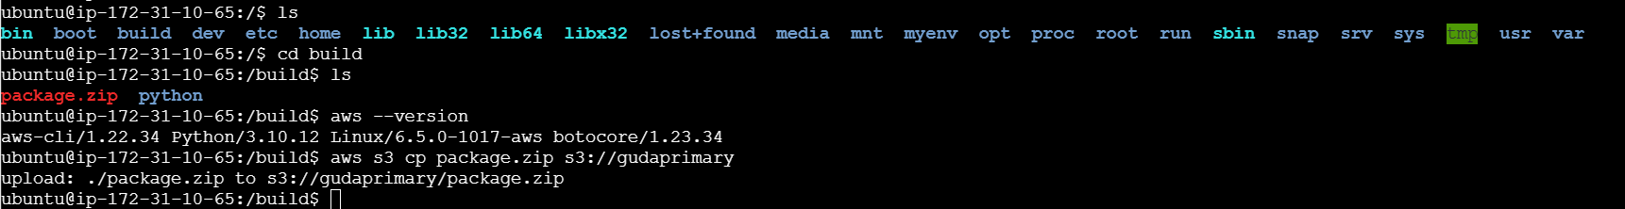

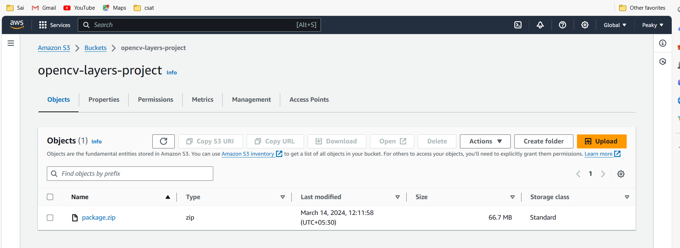

**Lambda Code Deployment**

**Title:** Deploying Lambda Function

* **Deployment:**
  + Create a layer in our lambda function and upload our zip file from S3 bucket. i.e. layers help the lambda function to import the packages required to execute our code.

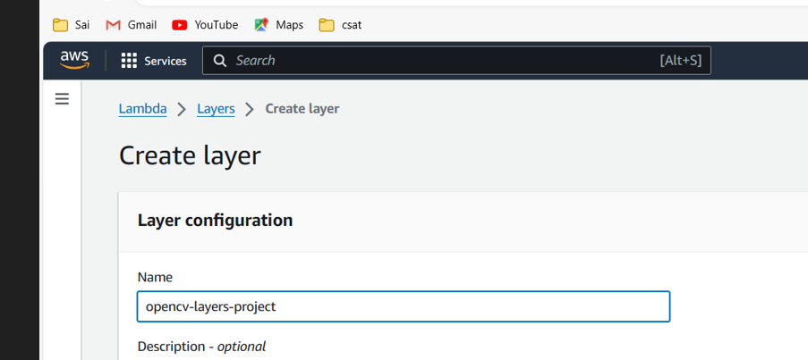

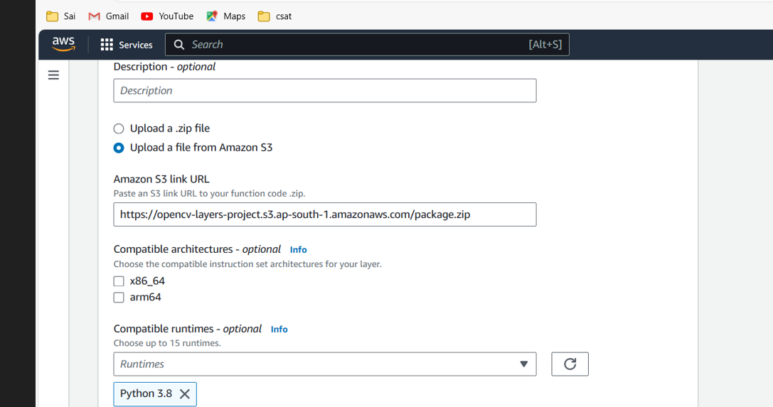

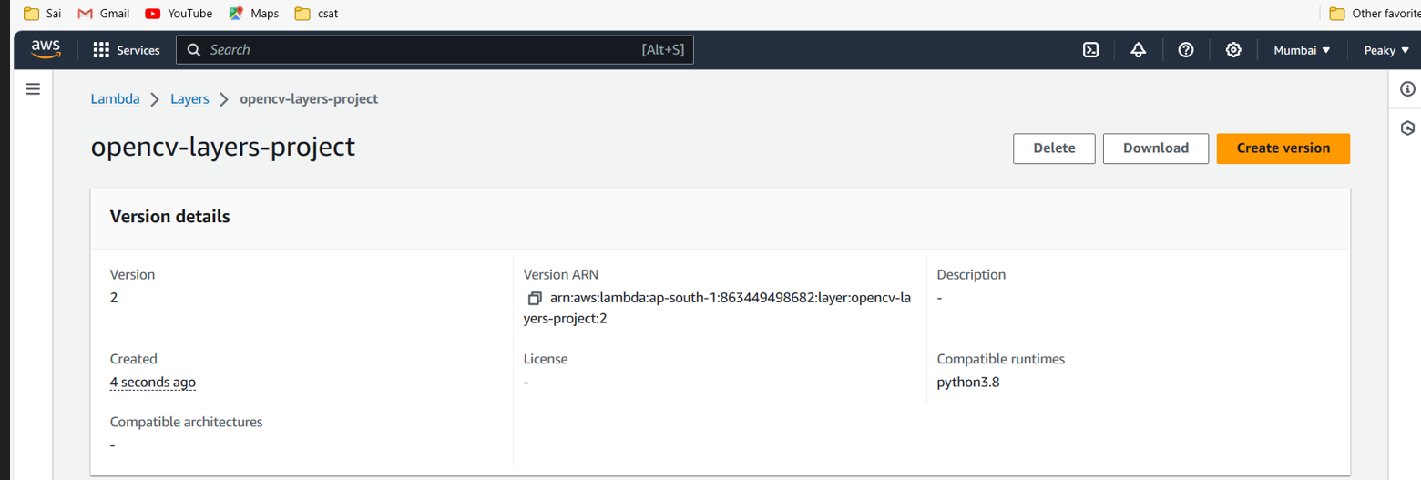

Add the layer that is created into lambda function.

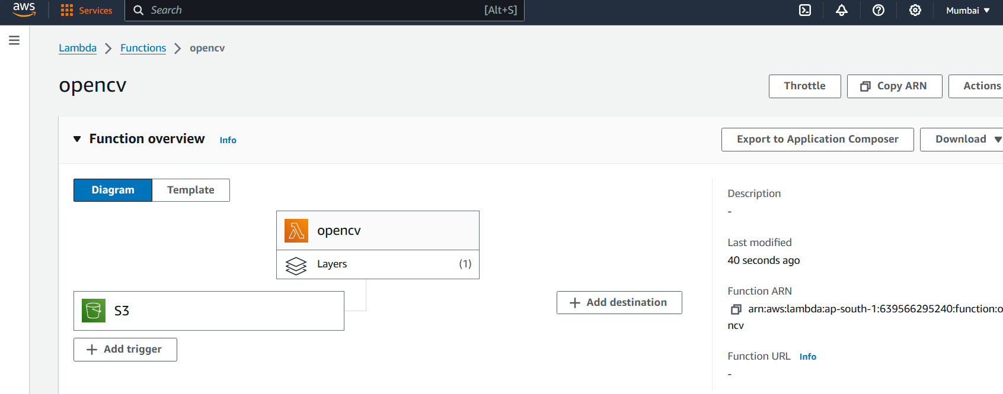

Now, upload this code in the lambda function:-

import os

import cv2

import boto3

import numpy as np

s3 = boto3.client('s3')

def lambda_handler(event, context):

try:

# Get the bucket and key from the S3 event

source_bucket = event['Records'][0]['s3']['bucket']['name']

source_key = event['Records'][0]['s3']['object']['key']

# Read the image from the source S3 bucket

response = s3.get_object(Bucket=source_bucket, Key=source_key)

image_content = response['Body'].read()

nparr = np.frombuffer(image_content, np.uint8)

img = cv2.imdecode(nparr, cv2.IMREAD_COLOR)

# Convert image to black and white

gray_img = cv2.cvtColor(img, cv2.COLOR_BGR2GRAY)

# Encode black and white image to bytes

_, bw_image_bytes = cv2.imencode('.jpg', gray_img)

# Destination bucket where the black and white image will be uploaded

destination_bucket = "gudasecondary"

# Upload the black and white image to the destination S3 bucket

destination_key = 'black_and_white_' + os.path.basename(source_key)

s3.put_object(Body=bw_image_bytes.tobytes(), Bucket=destination_bucket, Key=destination_key)

return {

'statusCode': 200,

'body': f'Image converted to black and white and saved as {destination_key}'

}

except Exception as e:

return {

'statusCode': 500,

'body': str(e)

}

Now, deploy the file, so it will save your code.

If you are get any errors, kindly edit the general configuration of lambda under configuration tab, increase the timeout seconds.

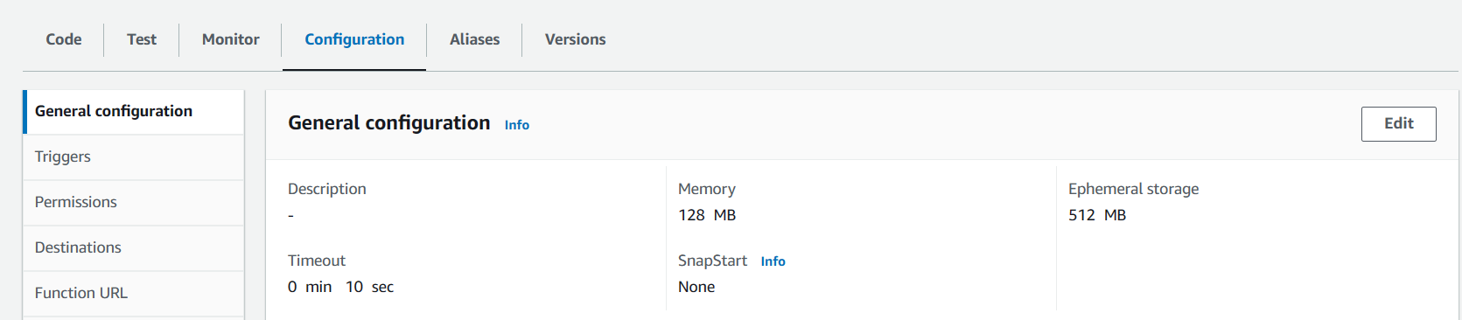

Now, upload a image in your primary bucket, in my case it is (guda-primary).

This will automatically trigger our lambda function to convert our image into black&white and uploaded back into our destination bucket as we mentioned in our code(guda-secondary).

My primary bucket with uploaded images…

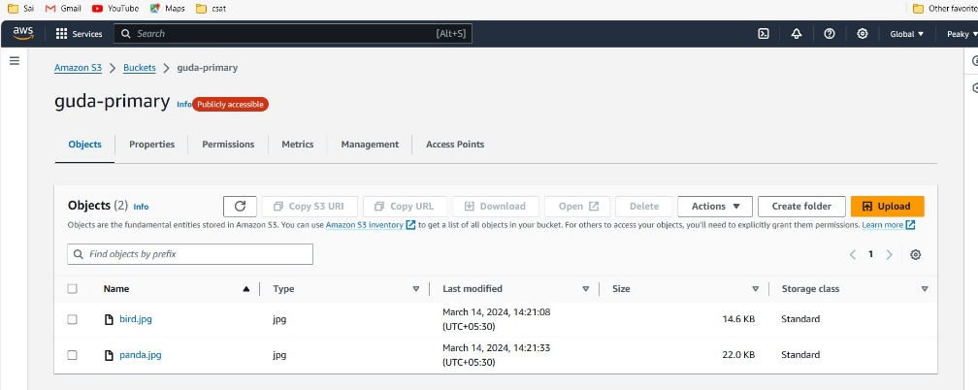

My secondary bucket with black and white conversion by lambda function….

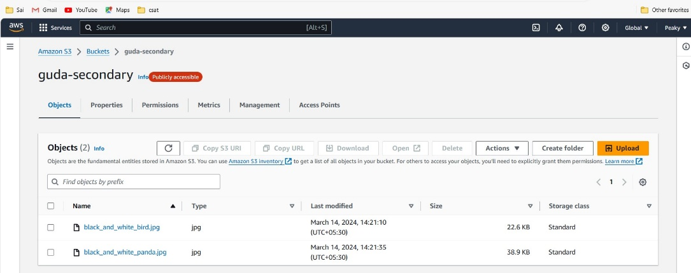

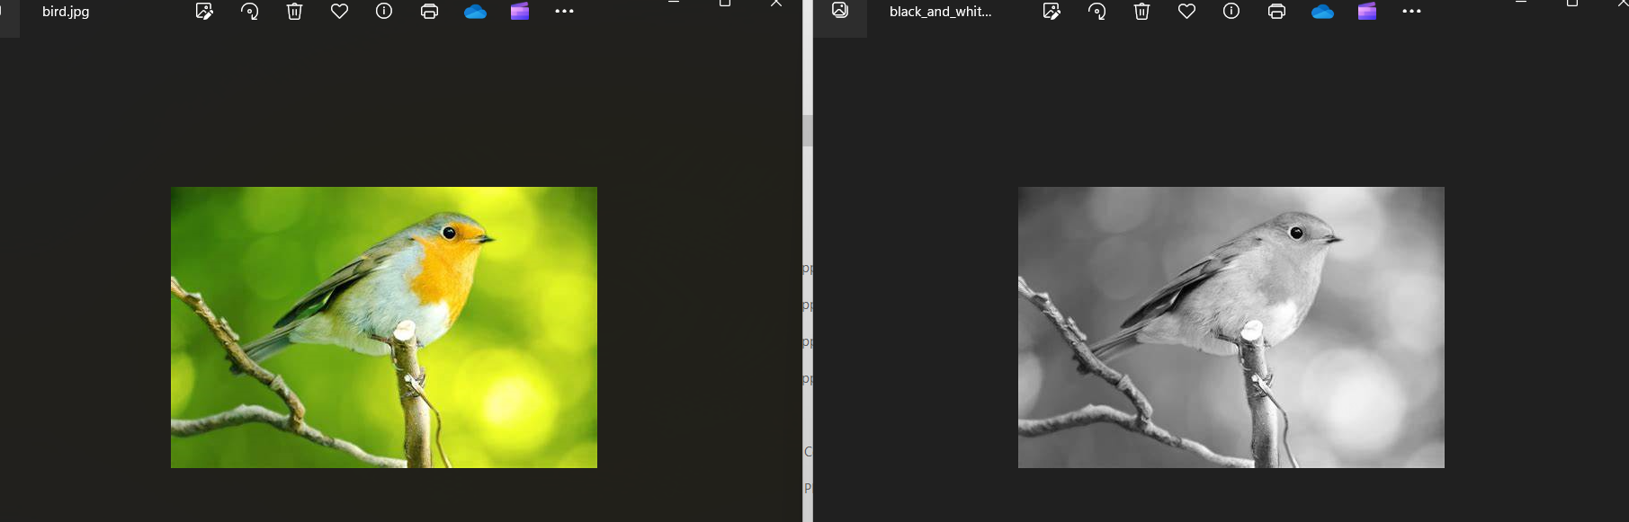

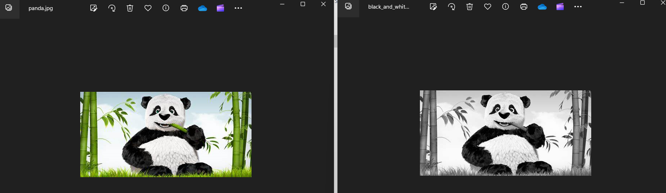

I hope you enjoyed the project in detail, I am giving a task to add the SES (simple email notification) service to this project and try it again.

Thank you,

Regards:

SAI GUDA